**Topic:** Abstract Classes and Interfaces

**Introduction:**

This assignment aims to enhance your understanding of Java programming concepts such as abstract classes and interfaces. These concepts will be used to develop a payment processing system that supports different payment methods such as credit card, debit card, and PayPal.

**Assignment Goals:**

* Develop an understanding of abstract classes and interfaces in Java
* Learn to use abstract classes and interfaces appropriately and for their intended use
* Develop problem-solving and programming skills
* Get a knowledge how to use a UML Diagram for software development.

**Assignment Description:**

The Payment Processing System is a Java program that allows a user to select a payment method (credit card, debit card, or PayPal), enter payment details, and process the payment. The program uses interfaces, abstract classes, and inheritance to implement the different payment methods and process the payment. It also includes exception handling to ensure that any errors during payment processing are handled gracefully.

**UML Diagram:**

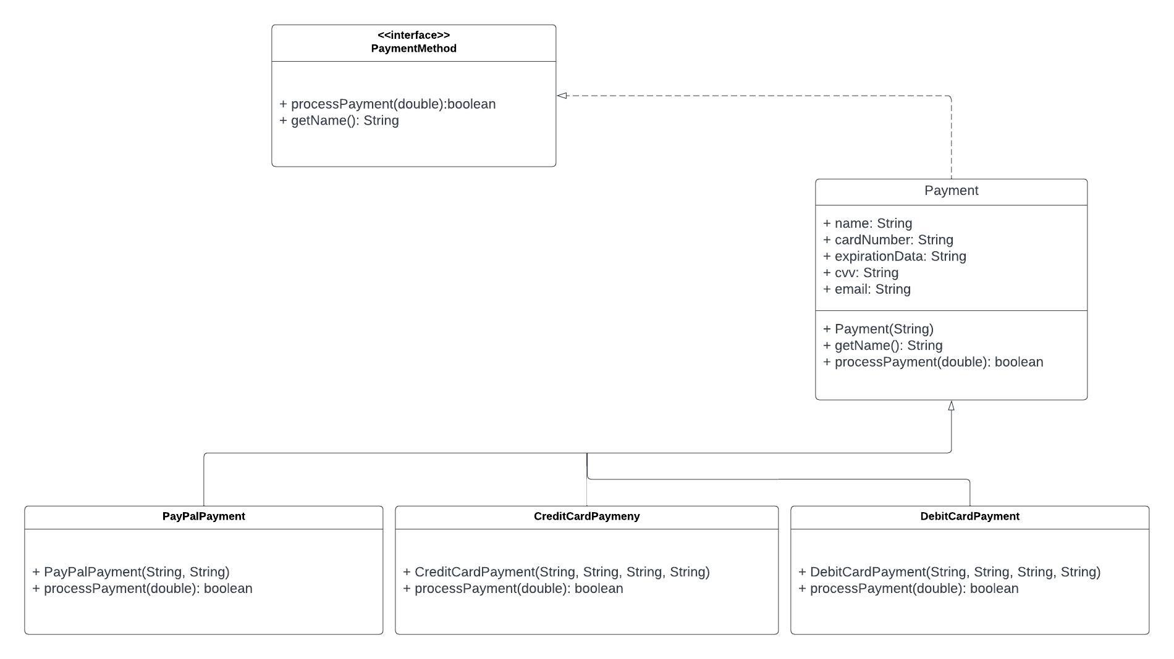

**Key:**

The key code has many files so it is provided Separately in the folder “Key Code”.